**Створив Когут Богдан**

**1. Install a Type II hypervisor on your home workstation – VirtualBox, VMWare Workstation, Hyper-V (or another of your choice).**

**2. Describe the set of basic actions in the installed hypervisor:**

* **Creating a new virtual machine**
* **Selecting/adding available hardware for the virtual machine**
* **Configuring the network and connecting to Wi-Fi access points**
* **Working with external storage devices (flash memory**)

**1. Creating a New Virtual Machine: (VirtualBox)**

* Open VirtualBox and click on the "New" button.
* Enter the name of the virtual machine and choose the type and version of the operating system (e.g., Windows, Linux).
* Set the amount of memory (RAM) for the virtual machine.
* Create or select an existing virtual hard disk for the VM.
* Click "Create" to finalize.

**2. Selecting/Adding Available Hardware:**

* After creating the VM, go to "Settings" for the virtual machine.
* In the "System" section, adjust CPU and RAM settings.
* Under "Storage," you can add or remove virtual hard disks and optical drives.
* In the "USB" section, you can enable USB controllers to work with external devices like flash drives.

**3. Configuring the Network and Connecting to Wi-Fi:**

* Go to the "Network" section in the VM settings.
* Choose the network adapter type (e.g., NAT, Bridged Adapter) depending on your networking needs.
* If using Bridged Adapter, you can access the internet via your Wi-Fi, making the virtual machine use the host machine's Wi-Fi connection.

**4. Working with External Storage Devices (flash memory):**

* In the VM settings, go to "USB" and enable USB controllers.
* After starting the VM, insert your USB device into the host machine.
* In VirtualBox, go to "Devices" -> "USB" and select the connected device to mount it to the virtual machine.

**Створив Трощинський Ярослав**



3. Install a GNU/Linux operating system (any distribution you like) in a basic configuration with a graphical program on your hypervisor.

For the purpose of learning how to create and install virtual machine, I downloaded a Virtual Box and an iso image of Linux Mint. To set up Virtual Box I had to tap a button “New”, name a machine, choose the ISO image of Linux Mint, and assign some power of CPU, RAM and hard drive. After that we can finish, and wait till Linux will download itself. After about 40 minutes the new OS was done and usable.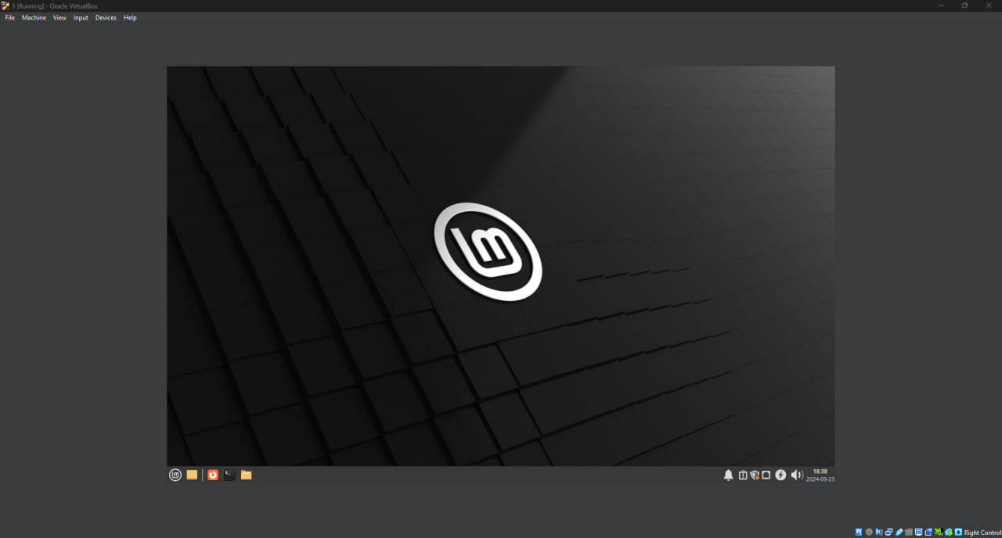

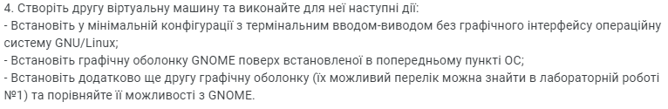

4. Create a second virtual machine and do the following for it:

- Install the GNU/Linux operating system in a minimal configuration with terminal input-output without a graphical interface;

- Install the GNOME graphic shell on top of the OS installed in the previous point;

- Additionally, install a second graphical shell (a possible list of them can be found in lab #1) and compare its capabilities with GNOME.

Using the previous method I installed another virtual machine, this time it is Debian. After this I opened the terminal and wrote these commands:

**First of all I have gotten a sudo rights by using this commands:**

su

*user password*

sudo visudo

*at the end of the file* *username* ALL=(ALL) ALL

*Ctrl + X* Y *Enter*

sudo usermod -aG sudo *username*

id *username*

**And now we have a sudo access, after that I began downloading Gnome with this commands:**

sudo apt update

sudo apt install gnome-shell

sudo systemctl start gdm3

sudo systemctl enable gdm3

gnome-shell --version

**After inputting the last command we have a current version of gnome being output in the terminal, and after a reboot we have a functional and customizable Gnome shell.** 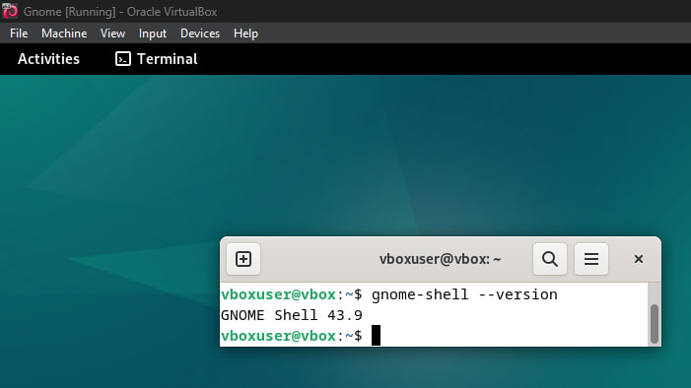

**For customization we need to first open the terminal through activities -> search -> “Terminal”, because the usual “Start menu” has disappeared. After that we need to have some commands to use:**

**gnome-extensions help – list of all usable “gnome-extensions” commands**

**gnome-extensions enable “extension” – enable an extension**

**gnome-extensions disable “extension” – disable an extension**

**gnome-extensions list – list of all extensions**

**After you use the last command you get a lot of different extensions, which you can use in pair with gnome-extensions enable “extension” to customize your OS. For example, using a command <gnome-extensions enable** [**apps-menu@gnome-shell-extemsions.gcampax.github.com**](mailto:apps-menu@gnome-shell-extemsions.gcampax.github.com)**> lets you get a new button called “Application” in upper-right corner near button “Activities”**

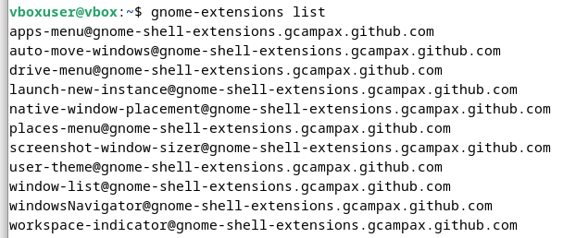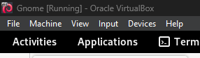

**Next I will install SDDM, for it I need to do:**

**sudo apt install kde-plasma-desktop**

**\*Choose sddm\***

**sudo systemctl start sddm**

**sudo systemctl enable sddm**

**After all of this we need to reboot the system and already at the start we will see the difference in lockscreen and after a few seconds in mainscreen too. For example I will also pin a Gnome version next to it.**

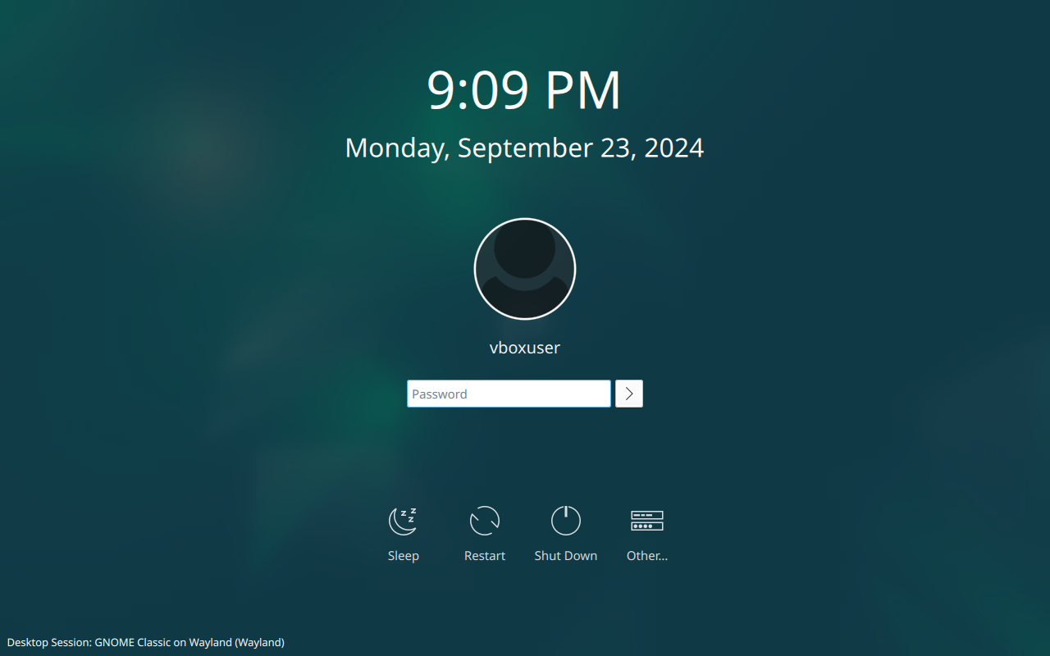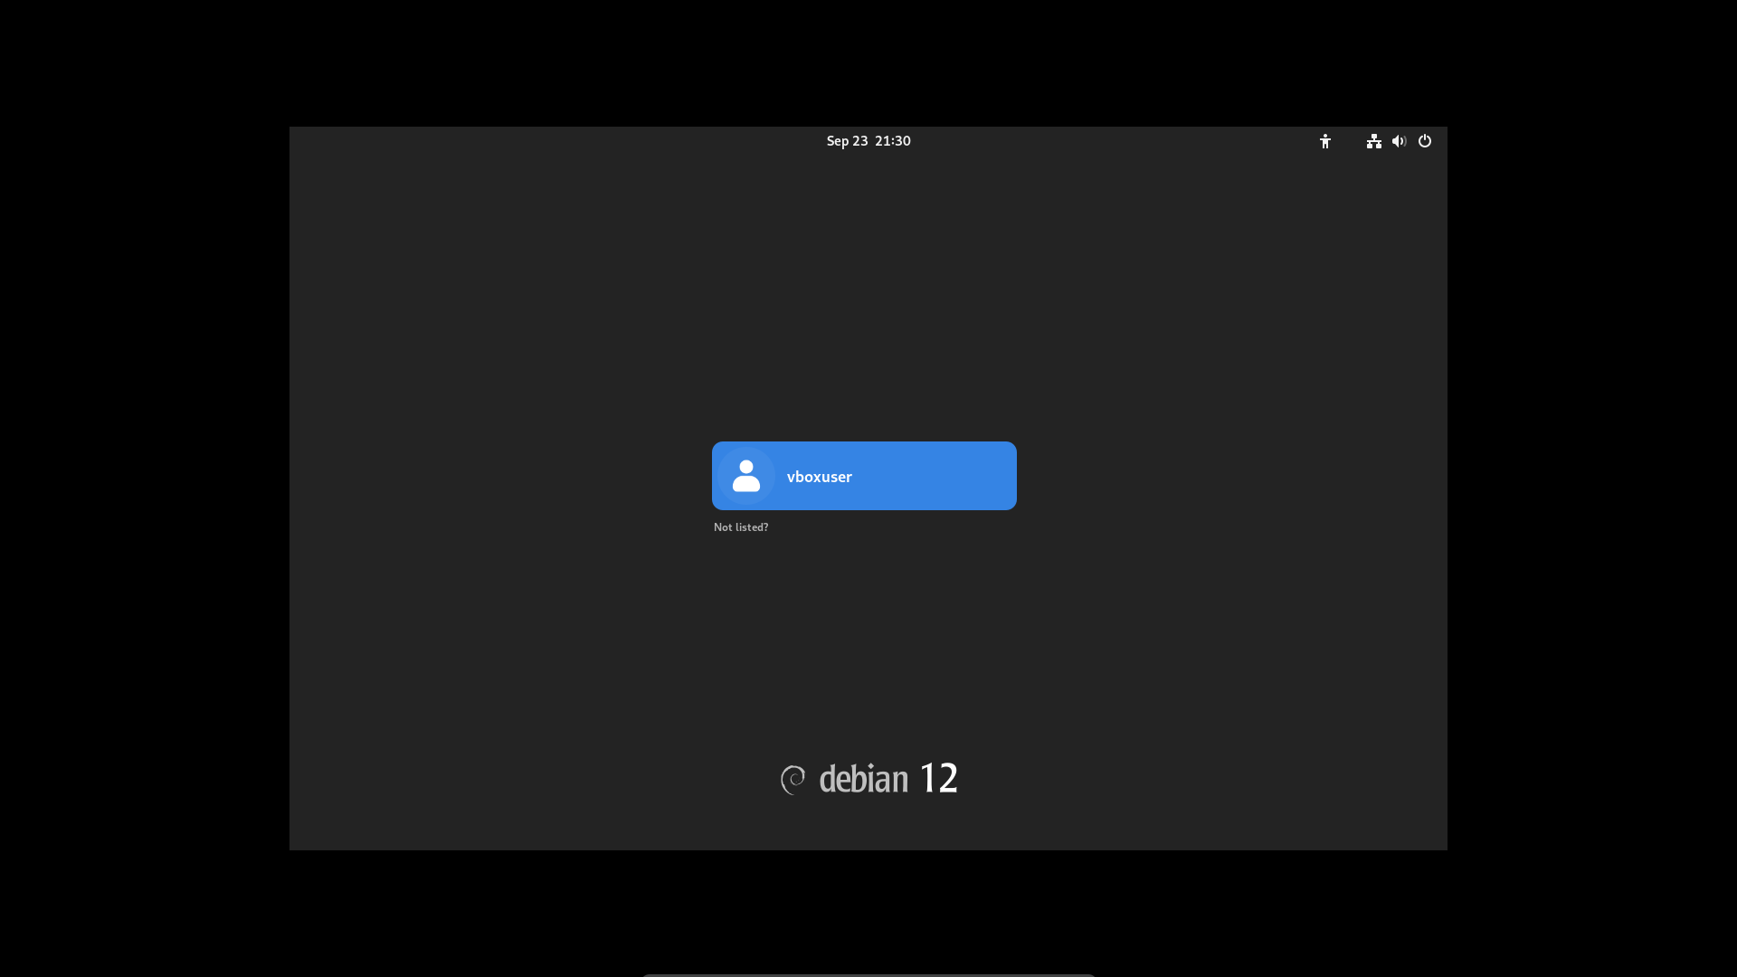

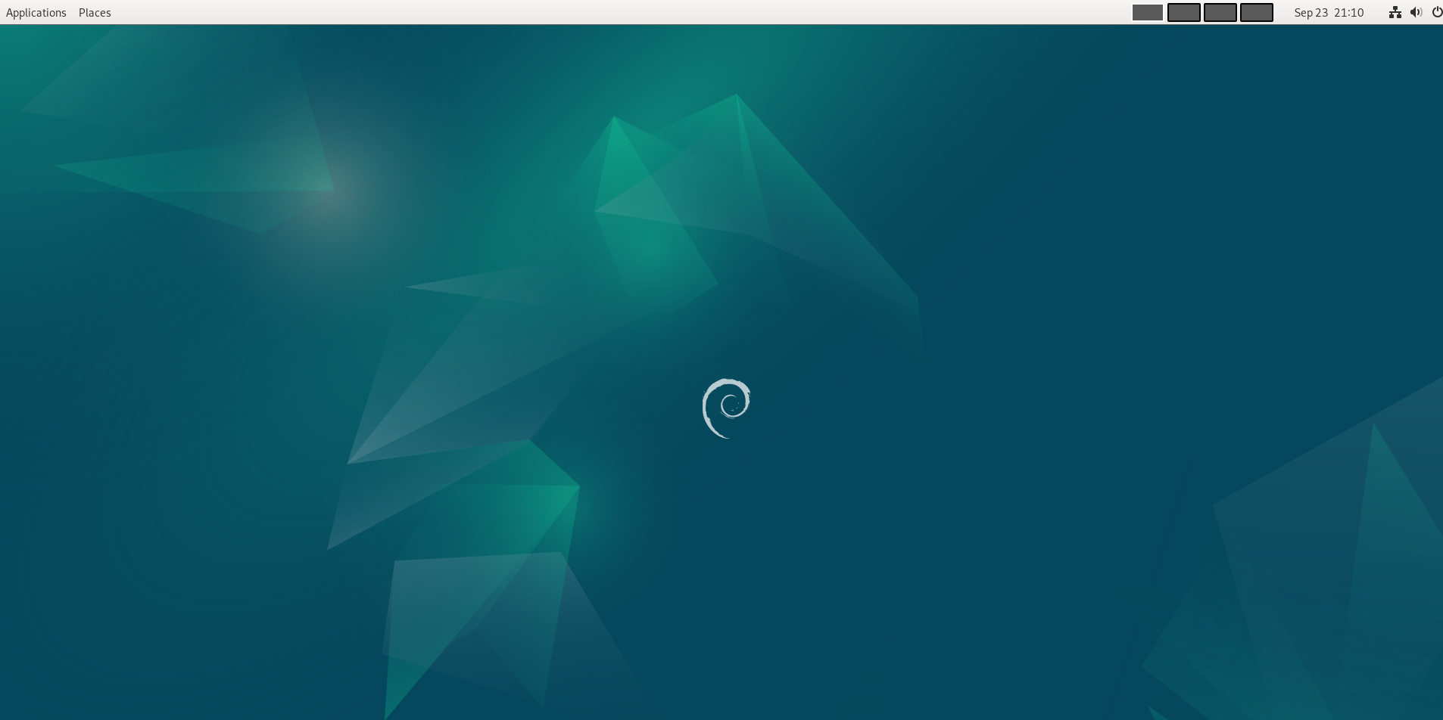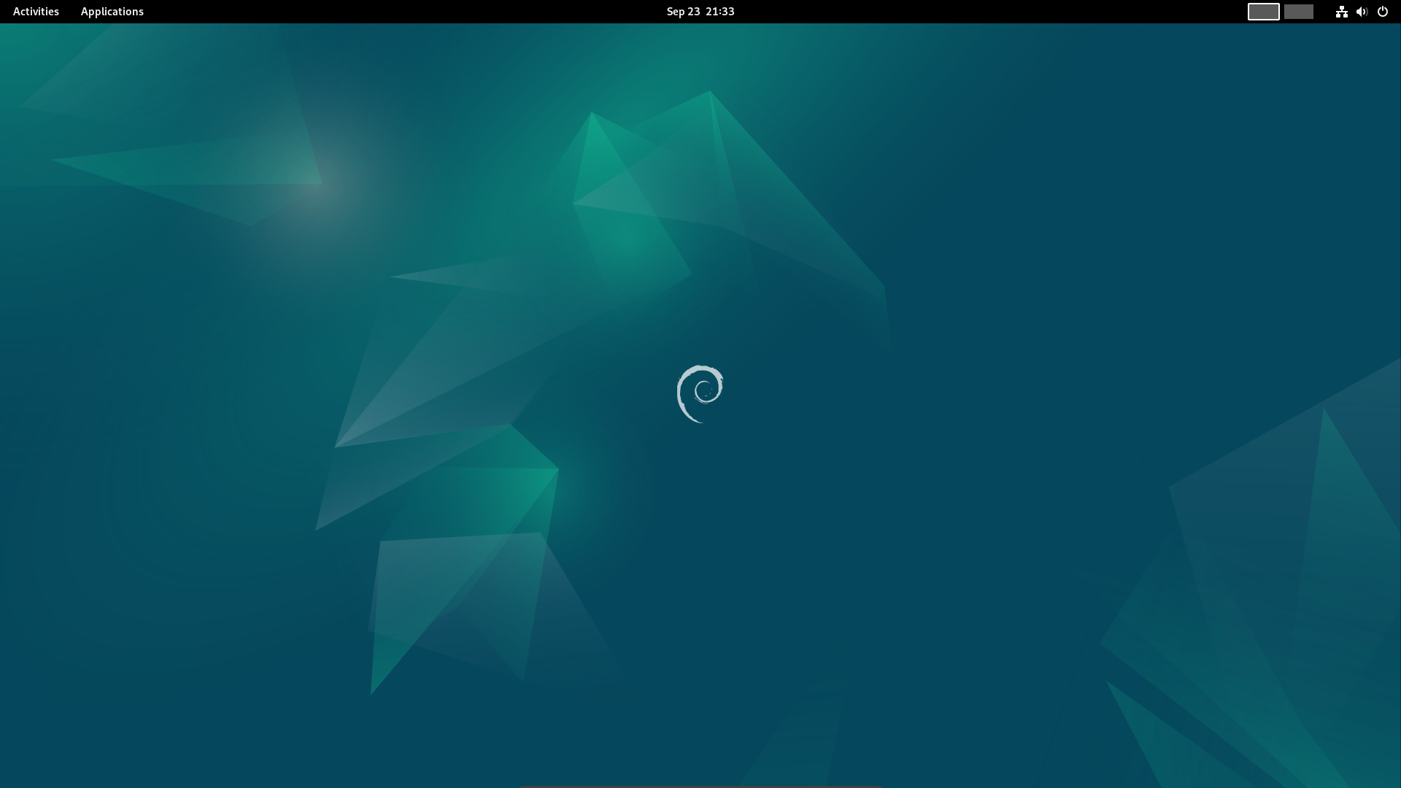**Especially, there will be new color palette of the system and other buttons like places and apps, also there will be a new type of terminal named “Konsole”**

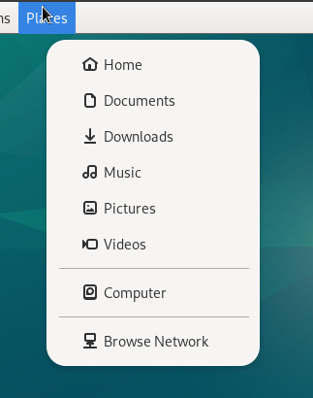

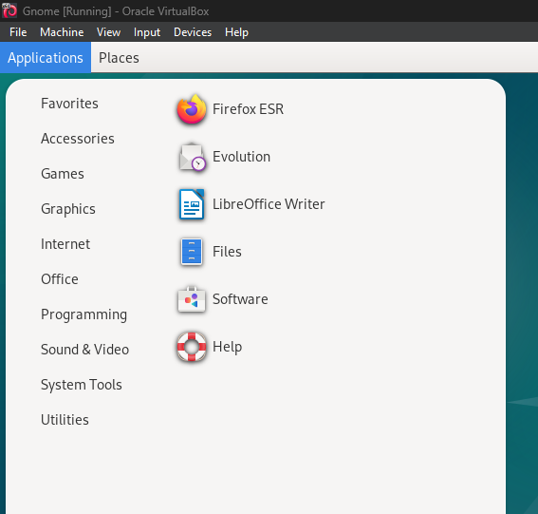

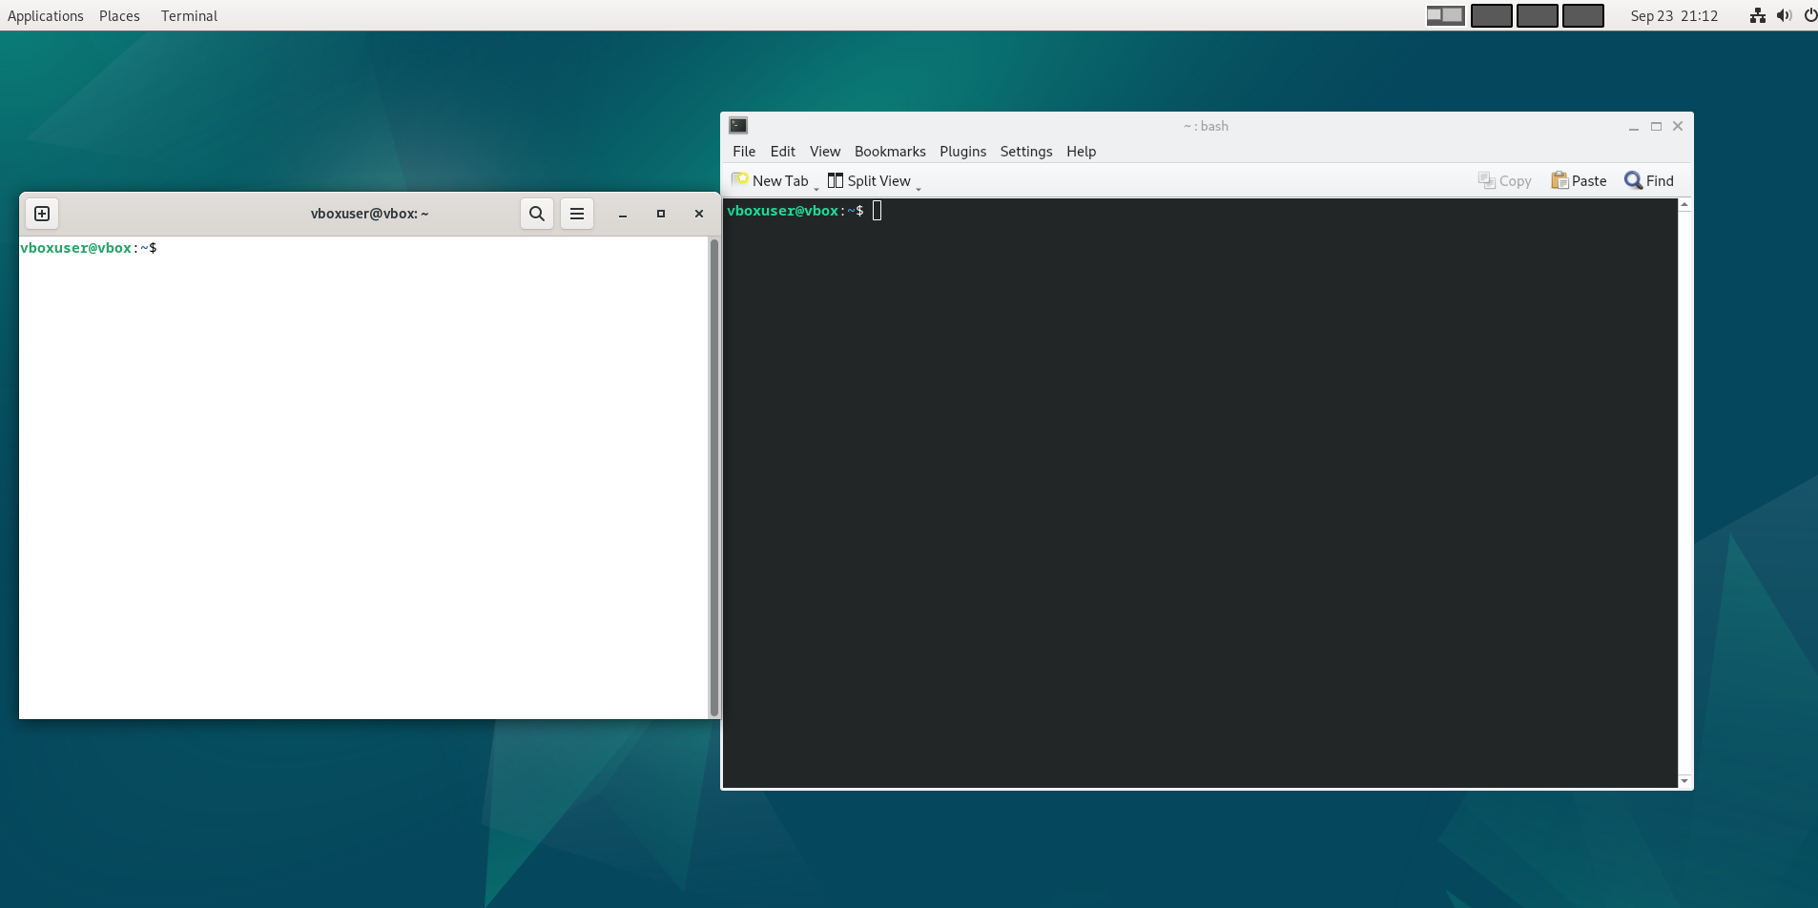

**Like Gnome, SDDM also can be customizable, but only with full themes. In my instance I had 3 themes: base one “debian-theme”, and two others “debian-breeze” and “breeze”. You can look and change your themes using these commands:**

**ls -1 /usr/share/sddm/themes – to look all the list of themes**

**sddm-greeter -- test-mode --theme /usr/share/sddm/themes/*name of the theme* – Opens a window with a test mode of chosen theme**

**For me is more interesting and beautiful is Gnome version other than SDDM, so I wanted to change it back, to do it I would need to write this commands in terminal:**

**sudo systemctl enable gdm3**

**sudo systemctl disable sddm**

**sudo systemctl start gdm3**

**And after a reload I have my beloved Gnome shell**